Just to recap, the process for QEW files is:
1. Create updated QEW locally (Ensure when doing this the below Analyse setting is set to 'No')
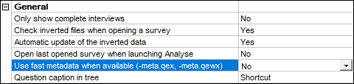​
2. Remove existing local FMD files
3. Open with latest Analyse version> Tools > Verify inverted database
4. Open with latest Analyse version> Edit > Recalculate all variables
5. Open with latest Analyse version> Edit > Generate fast metadata files
6. Open .qewx file in latest Analyse version to:
i) check all grouped/calc variables are all in place
ii) check grouped/calc vars counts have correctly updated
iii) check other relevant elements are in place e.g. weightings, filters etc
7. Upload the latest
i) .qew
ii) .dat
iii) -meta.qewx
iv) -meta.qex files
v) .qew-meta.dat
8. Reload survey

And the process for QES files is:
1. Create updated QES locally (Ensure when doing this the below Analyse setting is set to 'No' to begin with)
2. Remove existing local FMD files
3. Open with latest Analyse version> Tools > Verify inverted database
4. Open with latest Analyse version> Edit > Recalculate all variables
5. Open with latest Analyse version> Edit > Generate fast metadata files
6. Open fresh session of latest Analyse and set the below Analyse setting is set to 'Yes'
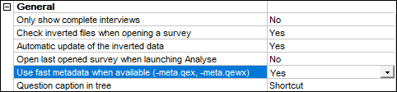​
7. Open updated QES file in latest Analyse version (In earlier versions of Analyse, you cannot open a .qex file in but with the above setting set to 'Yes' it reads the accompanying FMD -meta.qex instead of the .qes).

OR

In more recent versions, open the created FMD -meta.qex in Analyse – first you will need to copy the .dat folder and rename it so it matches the name of your .qex e.g.
- .qex name: - MySurvey-meta.qex
- folder name: - MySurvey-meta.dat

THEN
i) check all grouped/calc variables are all in place
ii) check grouped/calc vars counts have correctly updated
iii) check other relevant elements are in place e.g. weightings, filters etc
iv) once you are happy reset the Analyse setting shown above to be 'No'
8. Upload the latest
i) .qes
ii) .dat
iii) -meta.qex file
9. Reload survey

It’s good to add the registry key to create ADO warning log files somewhere e.g. D:\Askia\AskiaCtrl\Logs
(see ticket: https://dev.askia.com/issues/8987)

And Crash dumps somewhere e.g.
C:\Dumps

