Askia Vista 6 interface & settings
Main interface:
- New …
- Open …
- View …
- Questionnaire tree view …
- Survey settings …
- Miscellaneous question tree options …
- The response distribution panel …
- Miscellaneous tab definition settings …
- Table of contents / Download table …
- Save to portfolio …
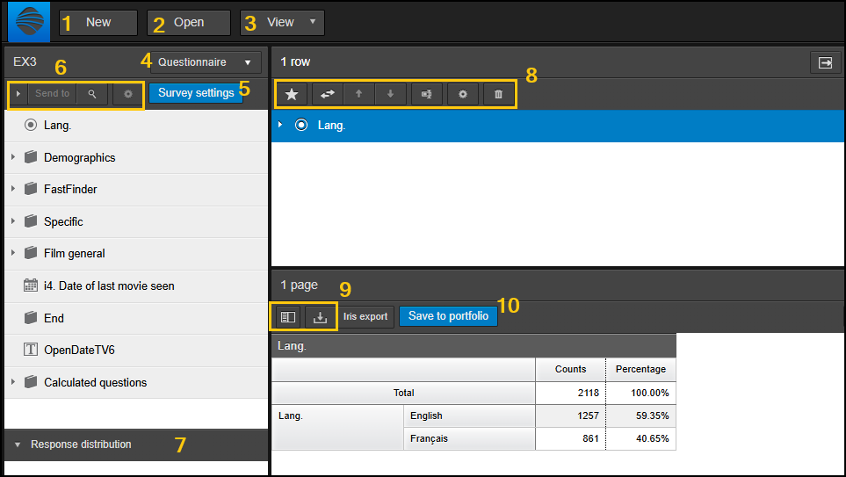
Properties panel:
- Collapse/hide the properties panel …
- Miscellaneous properties settings …
- General …
- Calculations …
- Rows …
- Columns …
- Edges …
- One question(s) selected …
- One response(s) selected …
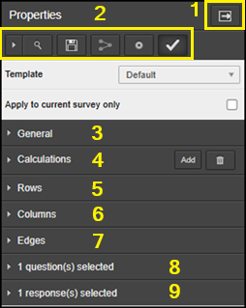

- [New] – Opens a new tab definition. Ensure you have saved existing tab definitions to portfolio if you need to revisit them
- [Open] – Opens a new survey.
- [View] – Here you can access your saved Filters, Variables and Portfolio links. You can also switch between regular cross-tab view and raw data view (if enabled in admin mode, authorisations). You can also add resources (image files to display on your portfolio links)
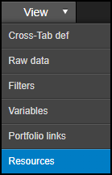
- [Questionnaire tree view] – The default is the questionnaire tree view. You can also switch the questionnaire tree to show you saved variables, profiles and portfolios. From here you can now drag saved profiles (lists of questions including saved settings) and derived variables into your tab definition to the right. You can also select a pre-saved portfolio to run and view a table within it using the ‘Run portfolio item’ button shown below.
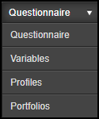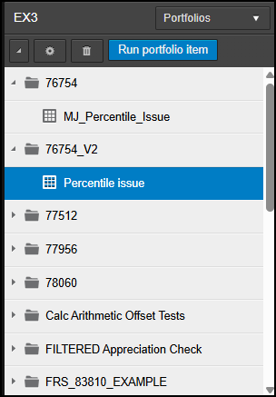

- [Survey settings] – Here you can set the various defaults shown below for your use of the current survey:
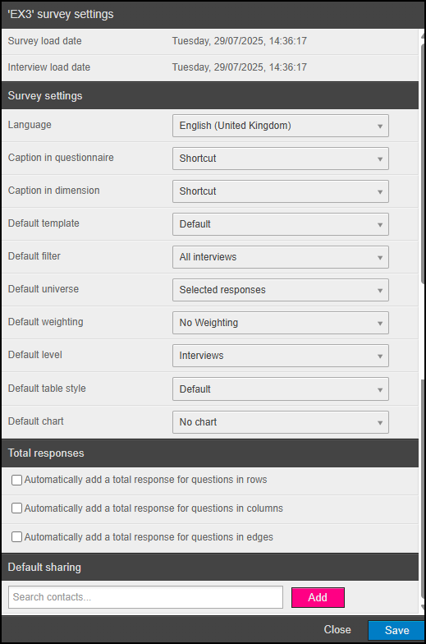

- [Miscellaneous question tree options]
  - The play button allows you to expand and collapse all chapters in the questionnaire tree
  - [Send to] – this allows you to send your selection in the question tree to either the rows, columns or edges of you table without having to drag the questions there
  - The magnifying glass button allows you to search text across the question names/captions
  - The cog button allows you to create one filter per response of any question you have selected
- The response distribution panel allows you to see the counts collected against each response of the variable selected in the questionnaire tree above.

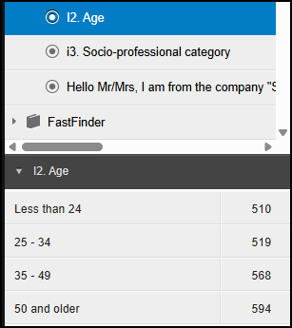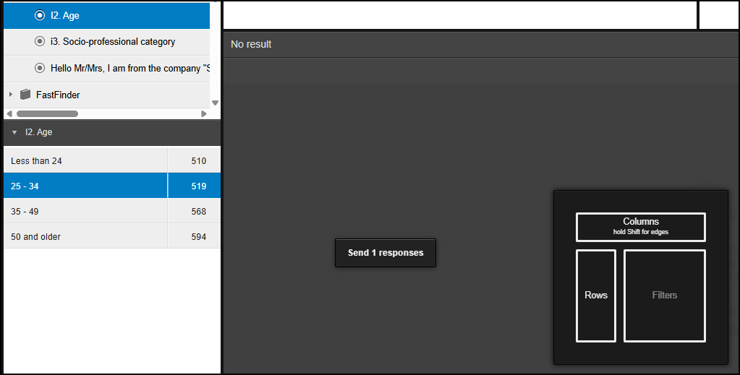
You can collapse this panel by hitting the downward pointing triangle. You can also drag a response on to your table as a temporary filter or as a variable (with only the selected response visible/selected in the tab definition)
- [Miscellaneous tab definition settings] – these buttons appear above the rows, columns and edges in the tab definition
  - The star button allows you to save a list of questions to reuse later, along with any formatting, analysis values, grouped/NET responses or calculated responses. These profiles can be used as additional questions available to end users in portfolio links
  - The dual, horizontal arrows button simply allows you to send one or more highlighted variables in the current dimension (i.e. row/col/edge) to another dimension
  - The up and down arrow buttons allow you to move a question in the list of questions or a response in a response list
  - The vice button allows you to rename a question in the rows or rename a response element
  - The cog button shows a different menu depending on whether you have question (left) or response (right) selected:

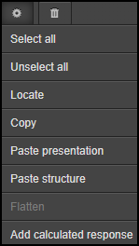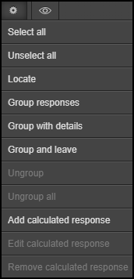

You can add NETS, add calculated responses, locate questions in the question tree, copy and paste formats, NETs and calculated responses from other questions.
  - The trash can button allows you to remove the selected question from the dimension you are in. Note that when you have a response selected instead of a question, the trash can icon changes to an eye icon. This allows you to select or deselect one or more responses to show in your results.

- The first button allows you to hide/unhide the table of contents panel. This is more useful for multi table results. The second button with the downward arrow allows you to export the current results to Excel. Next to this we have the ‘Iris export’ button – this is a deprecated feature out to another software for dashboarding.
- [Save to portfolio] – This brings up the list of portfolios you currently have access to and allows you to browse all portfolio items per portfolio as well. Here you can add the current table as an item to any portfolio or save over any existing portfolio items:
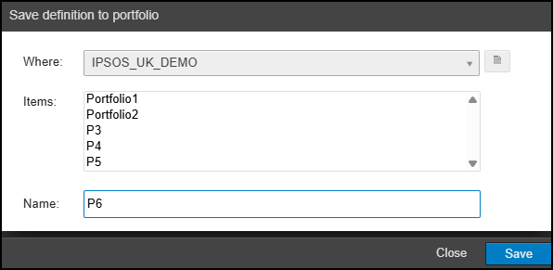
Now we move on to the ‘Properties’ panel which sits to the right of the tab definition and results:

- This arrow button allows you to collapse and expand the properties panel
- [Miscellaneous properties settings] –
  - The play button allows you to expand and collapse sections 3 to 9 below
  - The magnifying glass button allows you to search for a setting by text; e.g. below I have searched ‘chart’ and it lists different settings where this text is matched:
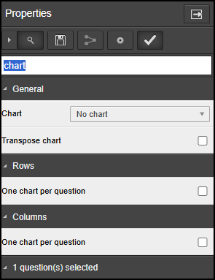
  - The disk button saves your current template settings to the list of templates shown below:
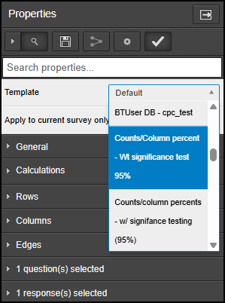
Note that, with the list expanded, you can press Ctrl+F to enable the web browser search functionality and search for template names in the list shown. This is particularly helpful when you have lots of templates saved with either long or very similar names.
  - The share button is to the right of the disk and this allows you to share the template you have saved (if you have the correct permissions to do this)
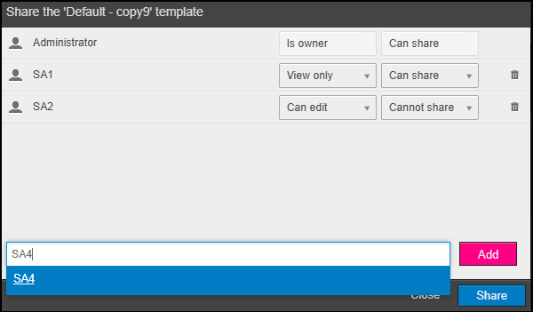
  - The cog button brings up the menu below. There are some more basic functions for tab templates but you can also customise table styles by uploading/downloading .css files and the same for chart templates by uploading/downloading zipped .json files. The chart templates use Highcharts with the following links coming in useful: Highcharts options & JS Fiddle - Highcharts
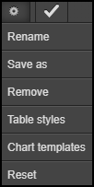

  - The tick button simply saves the current selected template to use as your default tab template

- [General] – this panel allows you to update general settings on your table
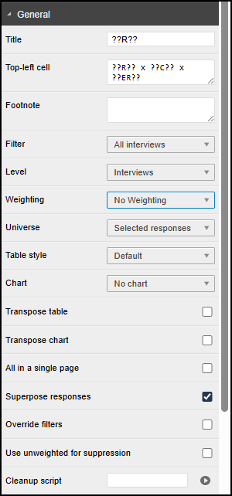
  - [Title/ Top-left cell/Footnote] - These allow you to add information about your tables to displayed/downloaded results. You can use the keywords set out in our documentation to substitute in variable tab details such as Base (??B??) or current sub-population used (??SP?? or ??SPD??)
  - [Filter/Level/Weighting/Universe] – Using these options you can change the named settings for your table. Note that weightings must be created in Askia Analyse first before importing in Askia Vista Admin mode prior to being available in the weighting drop-down menu. These settings can also be applied on the question (8.) or on the response (9.)
  - [Table style/Chart] – these options allow you to select different tab styles or chart types as discussed briefly in 2.e.
  - [Transpose table/Transpose chart] – these allow you to flip the dimensions of your table or chart
  - [All in a single page] – Sometimes you have tabs that produce multiple pages of results e.g. perhaps you have a chart that accompanies your data table or maybe you have one tab per edge response to produce multiple data tables. You will access the multi pages by the menu shown below:
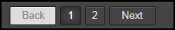
After ticking this option, you will then see all results displayed on one page:
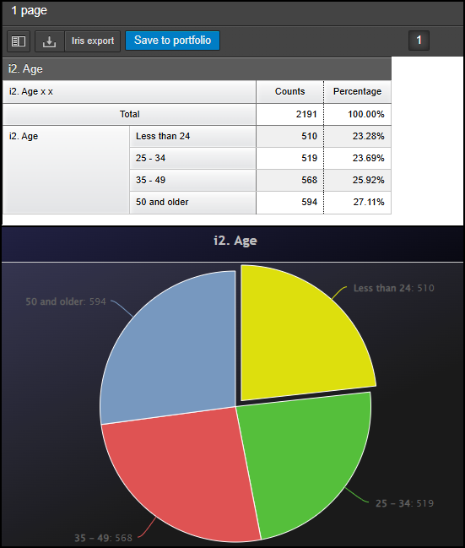
  - [Superpose responses] – if you have many questions with the same code-frame (number of responses and response captions) you can create a summary table without the questions having to be in a loop:
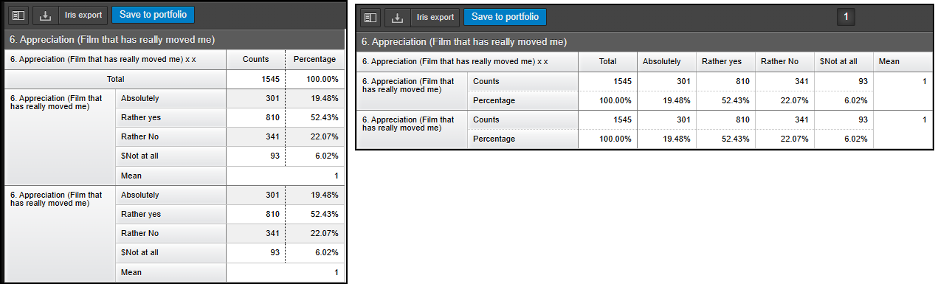
  - [Override filters (instead of intersecting them)] – You can apply a filter in the ‘General’ panel that affects your whole table, you can then also add filters on the questions and responses. This option will override what is set in the general tab with what is set on the questions and/or responses – the default behaviour is to combine (AND) the multiple filters when this is unticked
  - [Use unweighted for suppression] – On weighted tables, the suppression is carried out using the weighted data, by default. You can switch to using unweighted data with this option ticked
  - [Cleanup script] - this can be thought of as an advanced conditional formatting with the ability to move data around and perform calculations using your table’s results and other question properties – some examples can be found in our knowledge base: Cleaning scripts.
- [Calculations] – this panel allows you to show different data types e.g. Means, Counts, Percentages etc.
  - [Show caption] – the result of the calculations will be shown in the table, but their names/captions will not be visible
  - Here you can set how the calculations are to be displayed
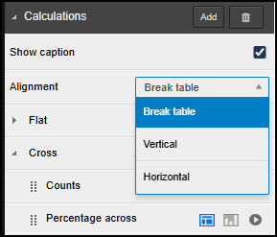

e.g. with Counts and % across selected
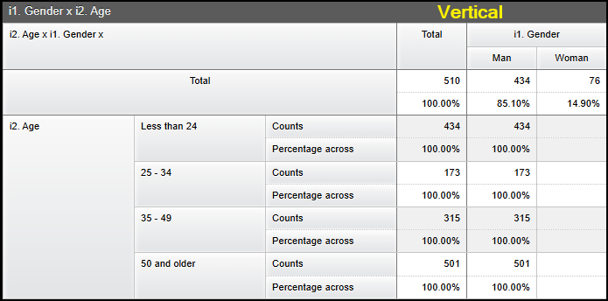

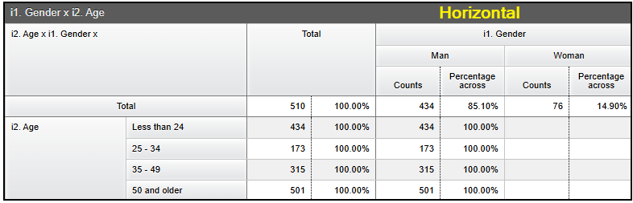

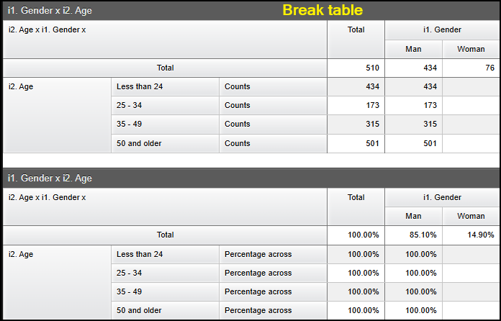

  - Now we have two sections [Flat] & [Cross] – The flat section is to only be used when you are updating calculations for a tab which has only questions in the rows or columns, i.e. a flat table

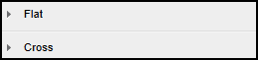

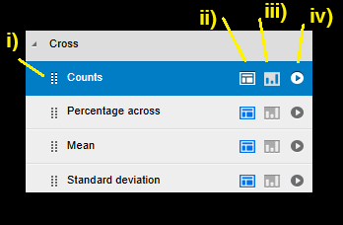
    - If you click these small dots and move the mouse it allows you to change the display order of your calculations
    - Enable or disable this calculation on your table results
    - Enable or disable this calculation on your chart results
    - Enter the properties of your calculations

  - Let’s expand on the calculation properties:
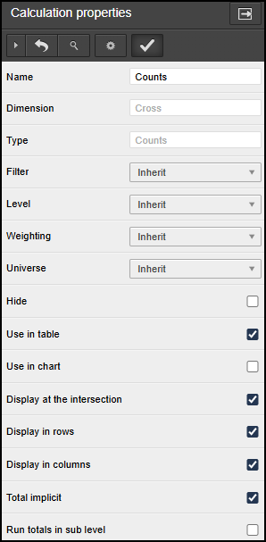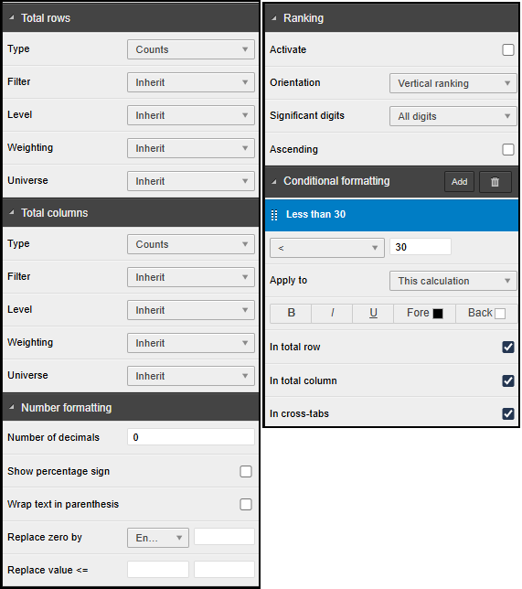

    - [Name] – allows you to rename the calculation
    - [Filter/Level/Weighting/Universe] – allows you to set one or more of these properties on the current calculation
    - [Hide] – allows you to hide the calculation but leave it available for conditional formatting or calculation arithmetic
    - [Use in table/Use in chart] – same as the functionality described in 4.c.ii) & 4.c.iii) i.e. disabling or enabling the current calculation for use in the table or chart
    - [Display at intersection] – with this unticked, your calculations will only show as row/col totals
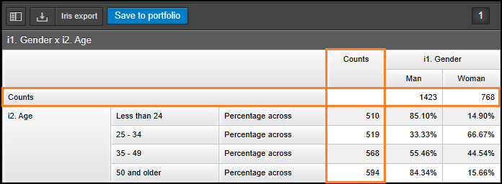
    - [Display in rows/Display in columns] – unticking these will remove the calculation’s row or column total as shown in the image above
    - [Total implicit] - If this option is cleared (de-selected), non-contextual totals will be used (i.e. the total will not necessarily correspond to the sum of counts present in the intersection of the cells). The Total rows and Total columns property categories will be accessible. You can then choose the calculation type, and the custom settings to override your in-built, default total. This option is available only for crosstab calculations.

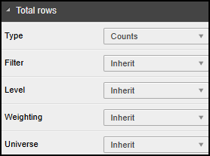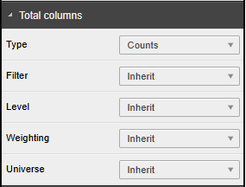

    - [Run totals in sub level] - if this option is selected, flat counts will be retrieved from the child level. This is useful when you want the counts in your table to be based on the data from inside a loop, not at the parent level.
    - [Number formatting] – this set of options allows you to change things such as decimal places, visibility of the % sign and nominate replacement text or symbols when the calculation values are below a certain threshold or equal to 0.

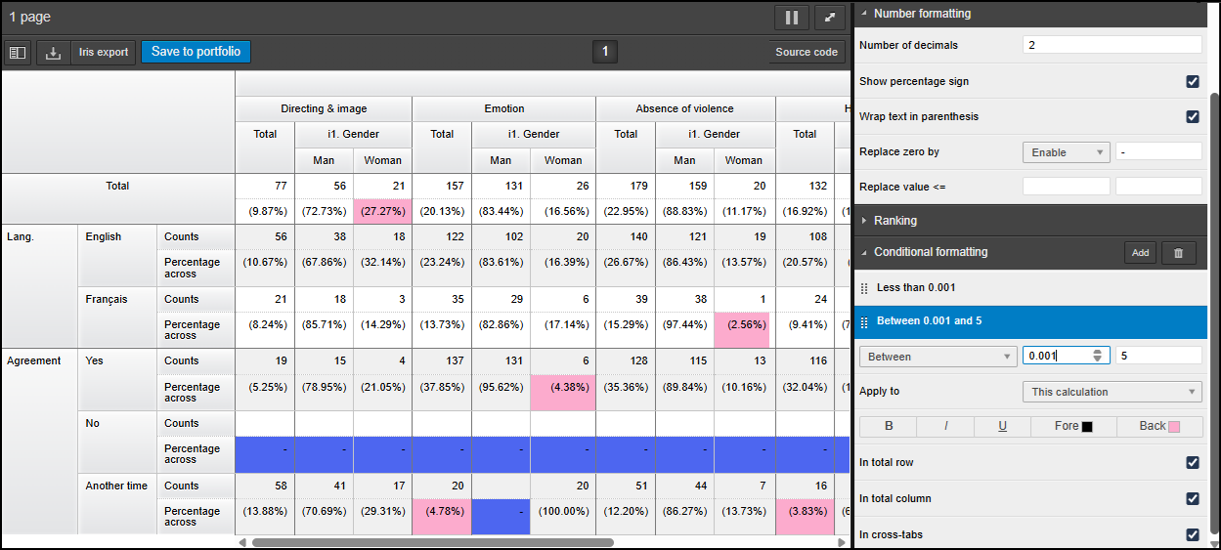

    - [Conditional formatting] – this allows you to format the contents of the calculation’s cell (or all calculations, totals etc. belonging to that cell) dependent on the return value. In the example above you can see that 0% (less than < 0.001) are first replaced by ‘-‘ in the Number formatting and then set to have a blue back-colour in the Conditional formatting. In addition, percentages > 0.001 and less than 5 are set to pink.

    - [Ranking] – This allows you to replace the results of the calculation with a ranking (either vertical or horizontal) of the values
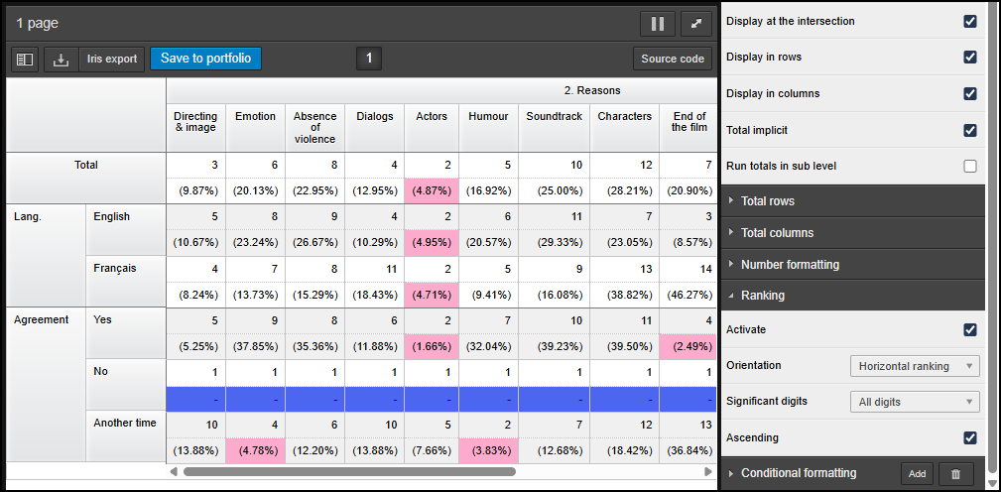
e.g. in the above example table, I have activated horizontal ranking on the count calculation. This replaces the actual counts with an ascending, integer rank number. In this case, the smallest count across all columns will be 1.

    - [Advanced options] – where necessary, some calculations allow for the calibration of the behaviour i.e. optional tweaks which change the calculation before returning values in the tables. The most extensive of these advanced options can be found in the column significance testing calculation shown below, left whereas other calculations have just a few options e.g. Standard-deviation estimator, or no advanced options at all for the majority.
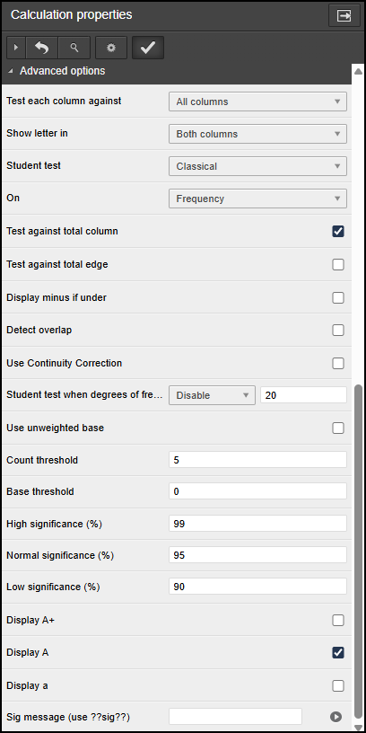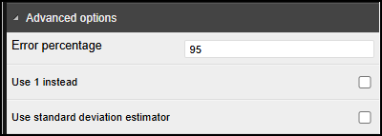
  - The last thing to mention is the two options at the top of the Calculations panel

[Trash can] – this simply allows you to delete any calculation you currently have highlighted
[Add] – this allows you to add a new calculation. You will be presented with the menu shown below where the possible calculations are arranged by type.

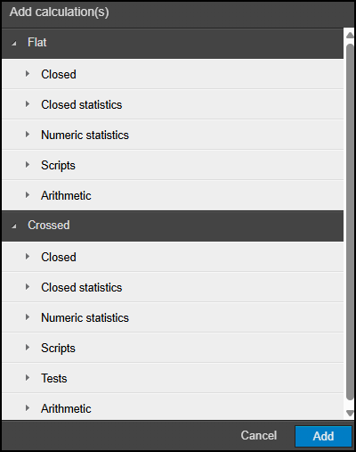

Now let’s remind ourselves of the different tabs in the properties panel (left) before we take a detailed look at the Roes panel:
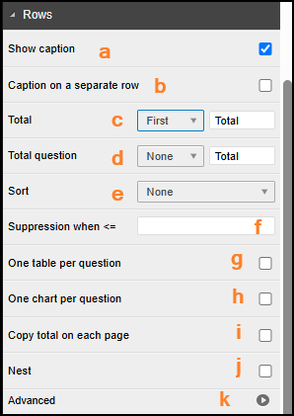

- [Rows] –

  - When ‘Show caption’ is ticked, you will see the row question’s shortcut appear first/left-most in the side-break. When this option is not ticked, the shortcut will not appear in the table.
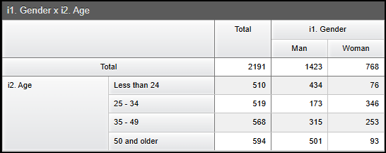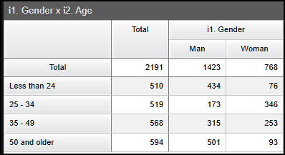

  - ‘Caption on a separate row’ will only work when ‘show caption’ is ticked. If both these options are enabled, the row question’s shortcut will appear above the row captions in a row on its own:
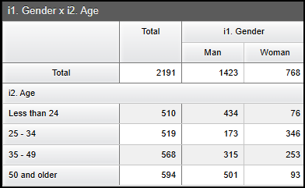

  - ‘Total’ will enable one row total for the entire table, even if there are multiple tables or row questions – this total represents the total number of respondents across all the questions in the rows
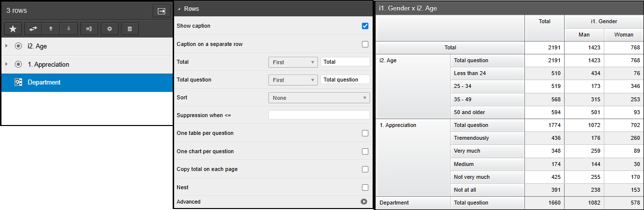
  - ‘Total question’ will enable one row total for each question in the rows.

The options for both these totals are: First/Least/None. None means these totals are disabled. Last means these totals are put at the bottom of the table or the bottom of the response list.

  - ‘Sort’ will allow basic sorting based on the row question’s counts of the total column. Advanced sorting based on other calculations, questions and settings will be available in the ‘Advanced’ section (k) at the bottom of the panel. The options for ‘Sort’ are: None/Descending/Ascending.
  - ‘Suppression when <=’ will allow rows to be suppressed when the row total count is less than or equal to the number you enter here.
  - ‘One table per question’ – with three questions in the rows, we will only see one table unless this is ticked. In which case you will see three separate pages for the three tables
  - ‘One chart per question’ – if each question also has an accompanying chart (and if ‘All in a single page’ is unticked in the General panel 3.e.) then you will see a separate page for each chart

e.g.
- If both options are ticked, then I will see six pages: - table then chart x 3
- If g. not ticked and h. is ticked, then I will see four pages: - combined table then chart x 3
- If g. is ticked and h. is not ticked, then I will still see six pages: - table then chart x 3 (split tabs = split charts)

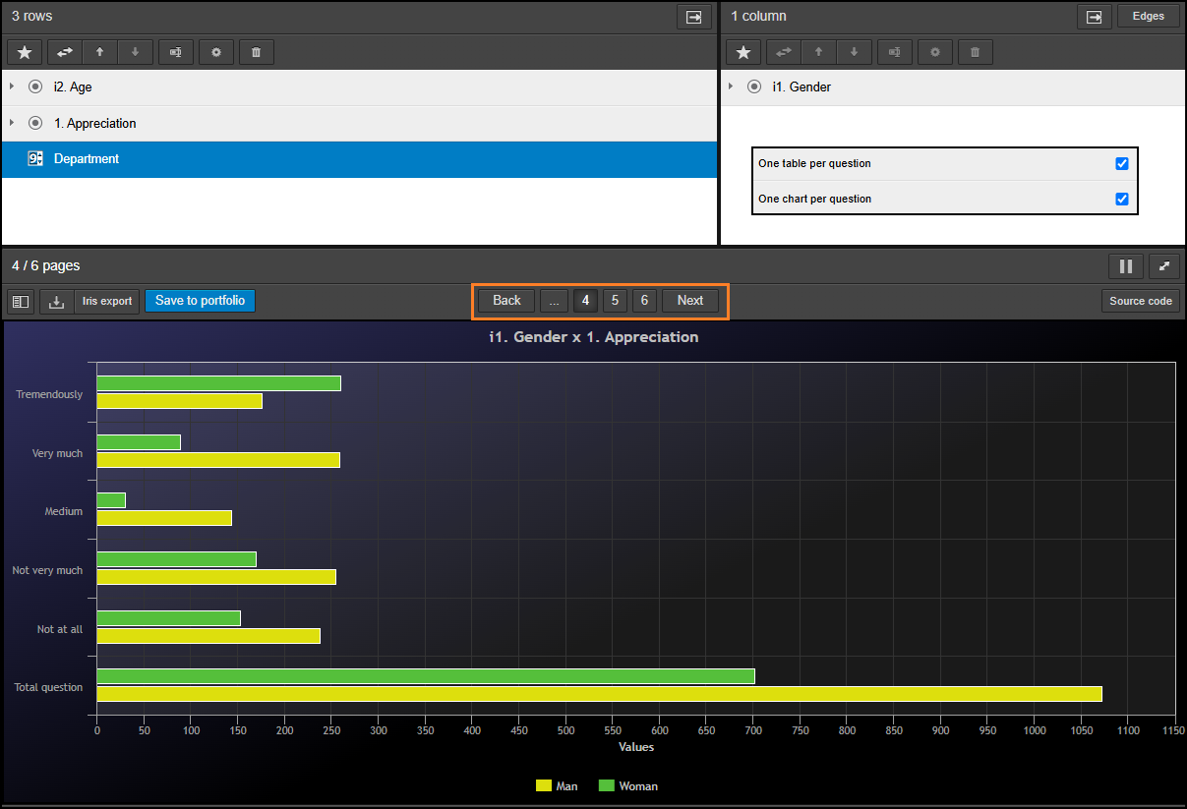
  - ‘Copy total on each page’ – This option comes into play when you have the ‘One question(s) selected’ > ‘Break table after’ option selected (see bullet point 8. later). Let’s this option is set on my first variable. Then my table will be split into two pages: Page 1 = 1st question. Page 2 = 2nd & 3rd questions. Without the ‘Copy total on each page option’ selected, page 2 will not show the total row (left) but when it is selected, the same total row from the 1st page will be repeated on subsequent pages (right).
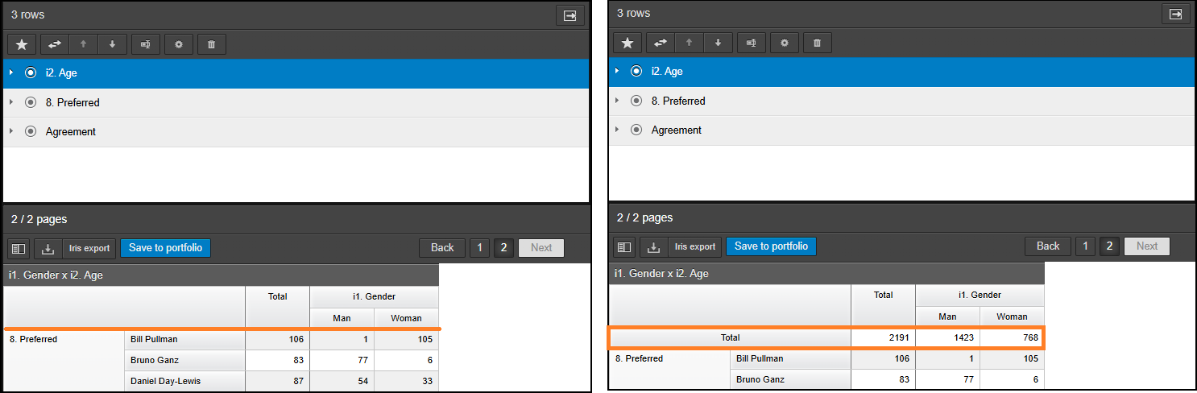
  - The ‘Nest’ option, when ticked, will cross the responses of separate questions in the rows rather than list them one question after the other when not ticked. It works the same as nested edges. Useful information on nested rows can be found in our knowledge base, here. In Vista, the nesting is limited to 300 resultant rows so as not to accidentally start processing tables which could hang for a long time and potentially lose unsaved work.
  - The ‘Advanced’ option will expand to show the panel below. Options outlined here.

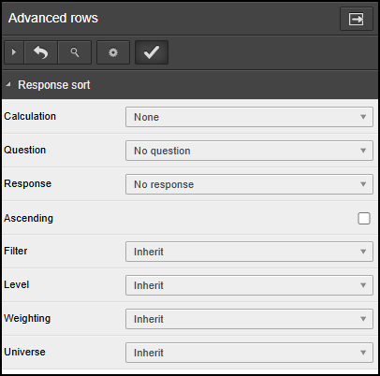

- [Columns] – The options contained in the Columns panel are the same as the previous section (Rows) only we do not have Caption on a separate row (5.b), Total question (5.d) and Nest (5.j). The explanations of the remaining options are as good as identical.
- [Edges] – The options contained in the Edges panel are the same as the previous section (Rows) only we do not have Caption on a separate row (5.b), Total question (5.d) and Copy total on each page (5.i). The explanations of the remaining options are as good as identical. The nest option here incorporates the column question into its crossing of responses.

- [One question(s) selected] –
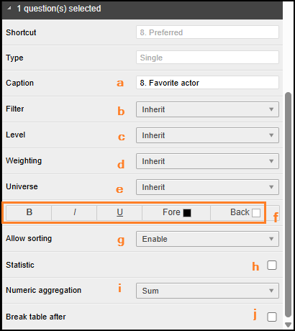
  - Change the caption of the selected question (same as using the vice icon, 8.d)
  - Set a different filter for the currently selected question
  - Set a different level for the currently selected question
  - Set a different weighting for the currently selected question
  - Set a different universe for the currently selected question
  - Set formatting options for the currently selected question
  - Turn sorting on or off for the currently selected question
  - Allow statistical calculations such as Mean, Median, Variance, SE, SD to be carried out on the currently selected question
  - Select the type of numeric aggregation to be carried out when dealing with stats calculations done in a level
  - Add a new table break after the currently selected question

- [One response(s) selected] –

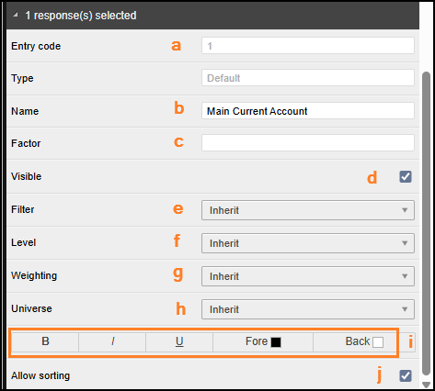
  - Shows the entry code related to the currently selected response
  - Change the caption of the selected response (same as using the vice icon, 8.d)
  - If you have allowed statistical calculations for the closed question, you can change the analysis factor associated with the currently selected response using this option
  - Changes the visibility of the response selected (same as using the eye icon, 8.f)
  - Set a different filter for the currently selected response(s)
  - Set a different level for the currently selected response(s)
  - Set a different weighting for the currently selected response(s)
  - Set a different universe for the currently selected response(s)
  - Set formatting options for the currently selected response(s)
  - Include or exclude the currently selected responses from response sorting

