Weighting does not converge error. What does this mean and how can I fix it?
You might see a warning message like this:
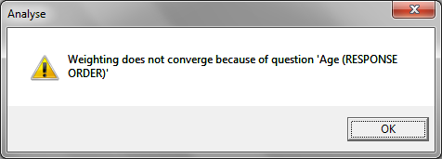
For weightings in Askia there are a number of options to take note of. 9 times out of 10, weighting convergence issues can be solved by adjusting these settings.
Number of possible iterations per question:
If the weigthing is a ‘difficult fit’ the weighting algorithm may need to cycle through a number of iterations before it can get to converge. If the number of iterations set in the options above is not high enough then the weighting may fail to converge.
Maximum and minimum weights:
When the weighting scheme has converged it assigns a weighting factor to each respondent. A weighting scheme may only converge once some respondents have been assigned a high weighting factor e.g. above 5. Then if it’s the case that your maximum weighting factor is set to 5, your weighting scheme won’t converge. The same goes for minimum weights.
How do we check for this? – right click in the question tree > create a variable > ‘By weighting’ > select the weighting.
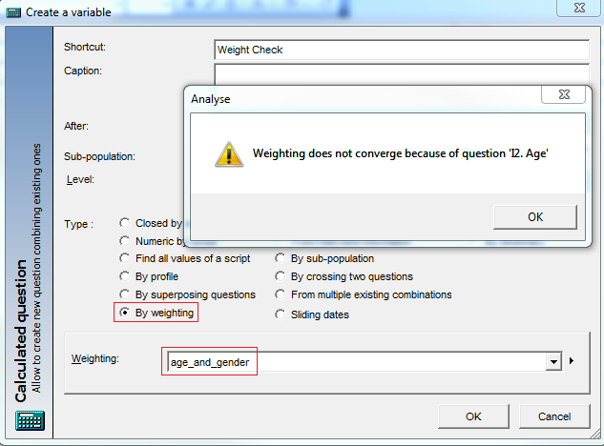
When you click OK you will see the convergence error but click OK again to create the variable. Now right click on it > group values > Find all values:
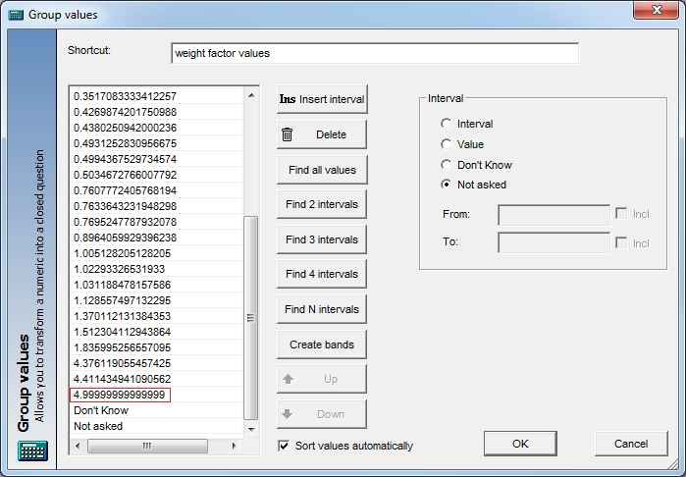
The maximum weighting factor like the one highlighted above (almost dead on 5) is a sure sign that the weighting has hit a limit which won’t allow it to converge. If I change my maximum weight to be 10 now and re-run these steps, my convergence warning does not appear anymore and my weighting factors look like this:
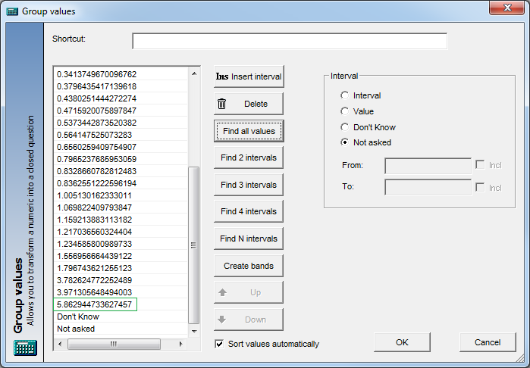
The other most common reason for convergence errors is when observed counts of 0 are given a target of greater than 0. There are no amount of iterations can turn zero into a number of respondents so the weighting won’t converge.
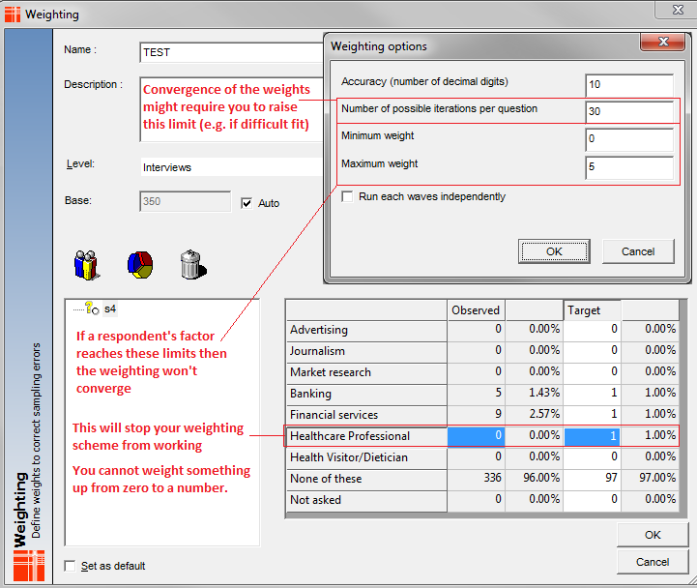
Finally, you could try reducing the accuracy of the weighting if all the other hints and tips have not worked.

