Programming Column Significance: Part 1 - (Classical Student Test)

Why would we need to program column significance?

Imagine we programme some simple table arithmetic
e.g. multiply vertical % figures together from two tables to give a final % figure in our final table.

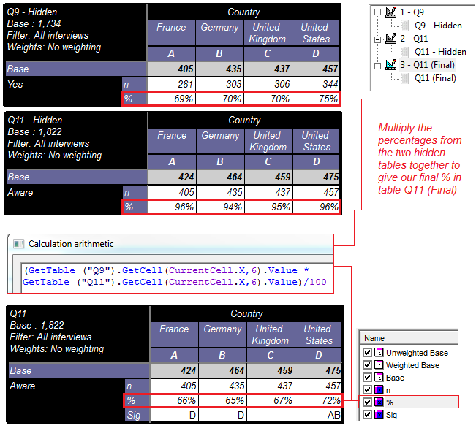

The % figure in our final table is no longer the pre-set ‘Percentage down’ calculation

But instead is now ‘Calculation arithmetic’ in order to carry out the multiplication of figures.

This means that our usual pre-set ‘Column significativity on closed’ calculation will no longer be sufficient because it does not work with n or % figures derived in calculation arithmetic.

So in order to get col sig based on the figures we see in our final table, we need to create another ‘Calculation arithmetic’ and programme the sig formula in here:
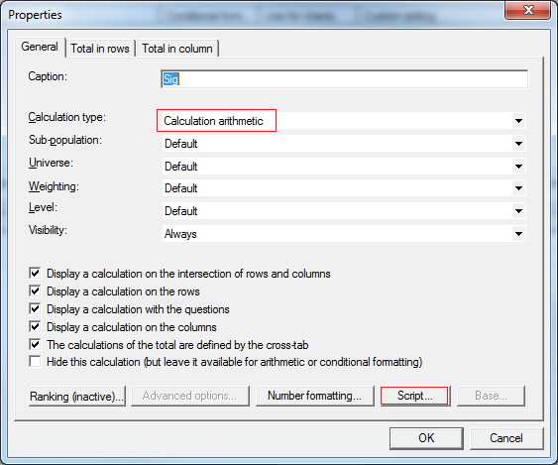

Before we start we need to know which sig formula we are programming. There are four different signicance calculations that Analyse carries out when comparing proportions:

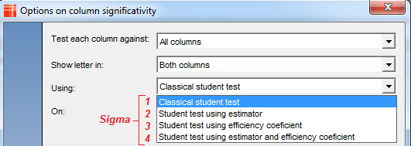

Formulas with efficiency coefficient are used when we have weighted data. In this example, we don’t but we will look at programming col sig with weighting in the next articles on programming column significance.

Here we use: Classical student test or Sigma1 as I will refer to it from now on.

As a bit of background, when we calculate col sig normally (pre-set calculation) we can get an output of the intermediary figures which result in the test (Sigma) values by setting the option below to ‘Yes’ in Analyse:

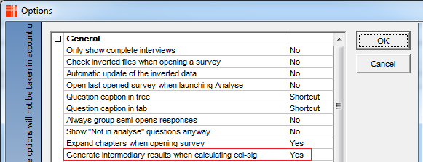
This is useful for checking the results you are getting with a manual col sig calculator or against a similar output from another software:

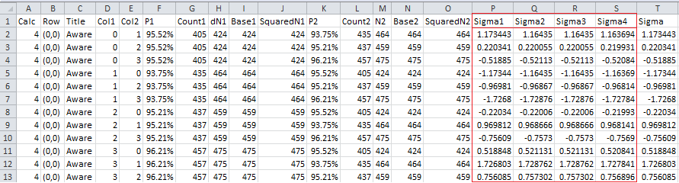

Now let’s proceed with looking at the formula & syntax to produce Sigma1:

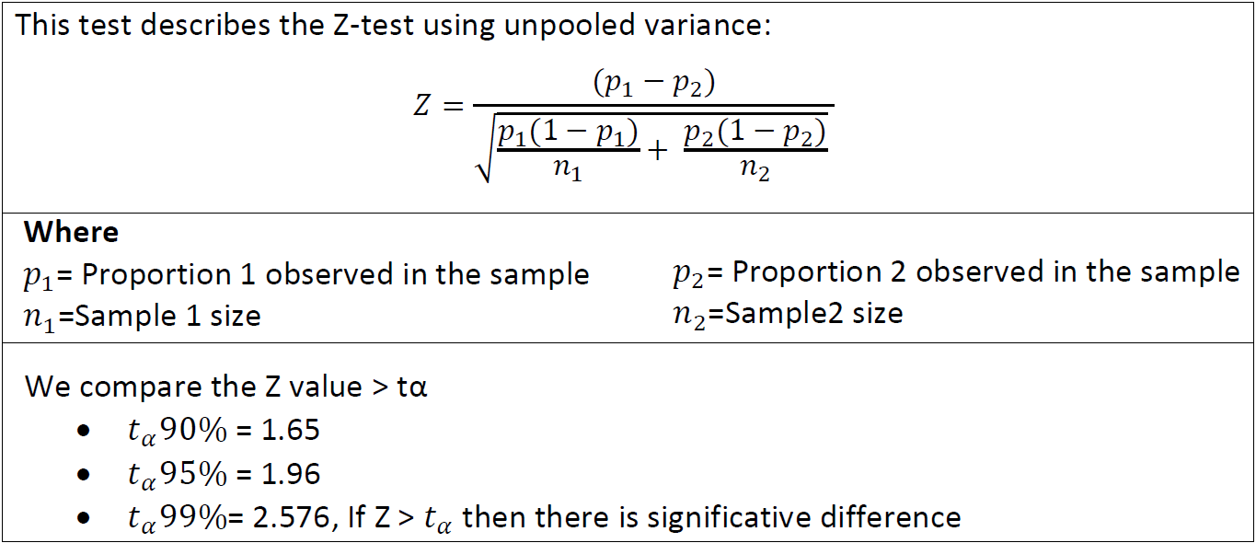

Dim dP1 = CurrentTable.GetCell(CurrentCell.X,CurrentCell.y-1).Value/100
Dim dN1 = CurrentCell.Row.Question.Data.FilterByX().Size()
Dim dA1 = dP1 * (1 - dP1) / dN1

dim strColSig = ""
dim strLastLetter = ""
Dim i
For i=CurrentTable.StartX to CurrentTable.MaxX
If strLastLetter <> CurrentTable.GetColSigLetter( i ) Then
strLastLetter = CurrentTable.GetColSigLetter( i )

Dim dP2 = CurrentTable.GetCell(i,CurrentCell.y-1).Value/100
Dim dN2 = CurrentCell.Row.Question.Data.FilterByX(i).Size()
Dim dA2 = dP2 * (1 - dP2) / dN2

dim dDenom = ( dA1 + dA2).Pow(0.5)
dim dSigma = ( dp1 - dp2).Abs() / dDenom

if dSigma > 1.96 Then
strColSig = strColSig + CurrentTable.GetColSigLetter( i,2 )
Endif
Endif
Next i

return strColSig

The parts of the syntax highlighted in yellow are those that reference the vertical % calculation we created by multiplying two previous %s together from separate tables.

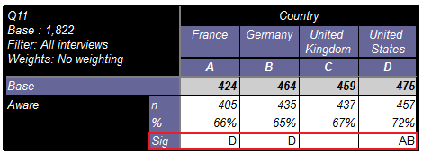

You can see how one would manually check these programmed significances in the attached Excel document (DebugColSig.xlsx)

Imagine you wanted to merely put the pre-set ColSig output (Colsig) side by side with the programmed ColSig output (#Colsig) as a check. This is shown in the tab definition: Q11 - Sigma1 (replica)

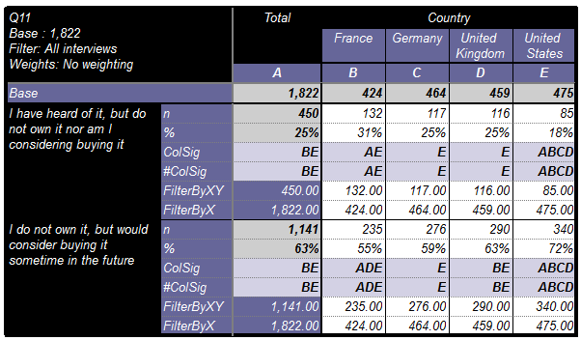

The syntax in this case can be refined:

Dim dP1 = (CurrentCell.Row.Question.Data.FilterByXY().Size() / CurrentCell.Row.Question.Data.FilterByX().Size())

Dim dN1 = CurrentCell.Row.Question.Data.FilterByX().Size()
Dim dA1 = dP1 * (1 - dP1) / dN1

dim strColSig = ""
dim strLastLetter = ""
Dim i
For i=CurrentTable.StartX to CurrentTable.MaxX
If strLastLetter <> CurrentTable.GetColSigLetter( i ) Then
strLastLetter = CurrentTable.GetColSigLetter( i )

Dim dP2 = (CurrentCell.Row.Question.Data.FilterByXY(i).Size() / CurrentCell.Row.Question.Data.FilterByX(i).Size())

Dim dN2 = CurrentCell.Row.Question.Data.FilterByX(i).Size()
Dim dA2 = dP2 * (1 - dP2) / dN2

dim dDenom = ( dA1 + dA2).Pow(0.5)
dim dSigma = ( dp1 - dp2).Abs() / dDenom

if dSigma > 1.96 Then
strColSig = strColSig+ CurrentTable.GetColSigLetter( i,2 )
Endif
Endif
Next i

return strColSig

Instead of referencing the vertical % from another cell / calculation, we calculate it in the script using the ‘FilterBy’ keyword. This method is dynamic because doesn’t rely on the position of the % calculation being fixed.

Finally, let’s take a look at how we can tweak the syntax to mirror some of the settings we can set in our pre-set ColSig advanced options:

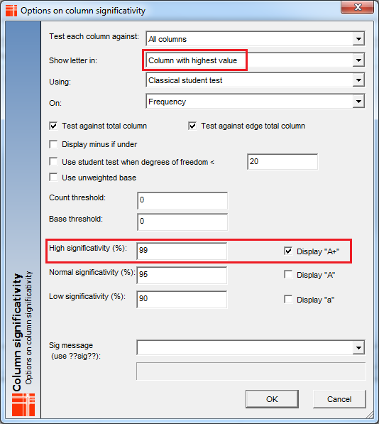

To mirror these settings we would change the part of the syntax highlighted in green to the below:

if (dSigma > 2.58 and dP1 > dP2) Then
strColSig = strColSig+ CurrentTable.GetColSigLetter( i,3 )
Endif
Endif
Next i

The result is in tab definition: Q11 - Sigma1 (replica 2)

Note the parameter for GetColsigLetter has been changed to 3 (99%) instead of 2 (95%). This is related to the strength (confidence interval) at which the test is done.

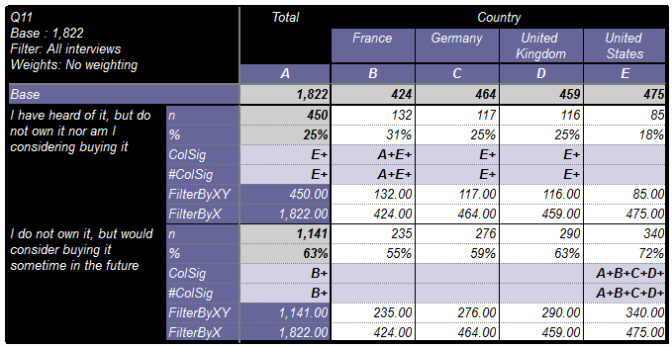

The strength (by default is 2) can be -3,-2,-1, 1, 2 ,3 to indicate the strength of the significativity.
The range of values this parameter can take (and return) are as follows:

1 returns a
2 returns A
3 returns A+
-1 returns -a
-2 returns -A
-3 returns -A+

Programming Column Significance: Part 2 will show the formulas and syntax for:

Student Test using estimator & Student Test using efficiency coefficient.

