New WebProd links
In v5.3.5 of WebProd we added 2 often-requested features: pretty URL’s and encrypted URL’s.

Overview
When starting a web interview, we normally need links like this:
http://askia.com/WebProd/cgi-bin/askiaext.dll?Action=StartSurvey&SurveyName=MySurvey
This has two main drawbacks:
- It isn’t very pretty to look at
- People can add/remove/modify parameters

Both issues have been addressed:
- We added ‘pretty’ links
- It’s possible to encrypt links

URL prettifying

To start an interview, you can now use a link like this:
http://askia.com/WebProd/Start/MySurvey
You have to admit this looks much nicer, no?

If post/redirect/get is enabled, you’ll also have a pretty link visible in the location bar while the interview is in progress. It will look like this:
Http://askia.com/WebProd/Interview/UCARYAZAJOBGLAGGWUFMKPOENKFEROBV
Instead of this:
http://askia.com/WebProd/cgi-bin/AskiaExt.dll?Action=DoInterview&Survey=UCARYAZAJOBGLAGG&Intvw=WUFMKPOENKFEROBV

Here’s the full list of available links to start an interview:
- StartSurvey:
  - http://askia.com/WebProd/Start/MySurvey
  - http://askia.com/WebProd/Start/SHFODHEPGNDOEHFA
- DoPanel:
  - http://askia.com/WebProd/Start/MySurvey/WMPDFOFNSLFOZNDLHDIADOAZHFOHDOH
  - http://askia.com/WebProd/Start/SHFODHEPGNDOEHFA/WMPDFOFNSLFOZNDLHDIADOAZHFOHDOH
- DoExternalPanel:
  - http://askia.com/WebProd/Start/MySurvey/Broker/BrokerPanelId
  - http://askia.com/WebProd/Start/SHFODHEPGNDOEHFA/Broker/BrokerPanelId
You’ll see that all links looks the same – the only way to see which link type is used is the number of parameters.

Note that it is still possible to add additional parameters. You’ll just lose some of the prettiness:
http://askia.com/WebProd/Start/MySurvey?Language=EN

URL Encryption

To prevent users from messing with the links, you can choose to distribute encrypted links instead of clear text links. An added benefit is that these encrypted links are also quite a bit shorter than the original links. That’s because known parts (like Action=StartSurvey) are replaced by placeholders.

This link for example:
http://askia.com/WebProd/cgi-bin/askiaext.dll?Action=StartSurvey&SurveyName=MySurvey
Would be encrypted to something like this:
http://askia.com/WebProd/~O1p1PnpkpSI

A DoExternalPanel link (which is normally quite long), will also be quite a bit shorter.
This link for example:
http://BERTR-PC/WebProd/cgi-bin/askiaext.dll?Action=DoExternalPanel&Survey=PAVCAHBAMRSGUAGB&Broker=123&BrokerPanelId=abcdef
Will become something like this:
http://BERTR-PC/WebProd/~9Q6fW1qhe2QV3edpNKJi_Q

Extra parameters are also possible, but the encrypted link gets a bit longer.
This:
http://askia.com/WebProd/cgi-bin/askiaext.dll?Action=StartSurvey&SurveyName=MySurvey&Test1=abc&Test2=123
Will become something like this:
http://askia.com/WebProd/~Q8eKHqMooeHBGuKJ3a5V4Ljz-ztnYw0ac0LdEH!H97k
Which is quite a bit longer than the link above

Encrypting an URL

To get an encrypted URL you can use AskiaExt as well, using the Action=EncryptLink, and the parameters (the part after the question mark) as the ‘Link’ parameter.
For this request for example:
http://askia.com/WebProd/cgi-bin/askiaext.dll?Action=EncryptLink&Link=Action%3DStartSurvey%26SurveyName%3DMySurvey
You will get a plain text encrypted value back like this:
O1p1PnpkpSI
To use this in a link you have to include the prefix yourself (including a ~ to indicate this is an encrypted link). So in our case we have to start each link with http://askia.com/WebProd/~

Note that you have to URL-encode the link parameter!
So instead of using
Link=Action=StartSurvey&SurveyName=MySurvey
You have to use
Link=Action%3DStartSurvey%26SurveyName%3DMySurvey

It’s also possible to use a ‘pretty’ version of this command which doesn’t require URL encoding:
http://askia.com/WebProd/EncryptLink/Action=StartSurvey&SurveyName=MySurvey
Will also return the encrypted value

Installation

Enabling this is optional, and not difficult at all.
All this functionality is provided by an embedded ISAPI filter, which allows us to intercept and change URL requests.

Enabling this is as easy as installing the ISAPI filter.

Here’s how:
- In IIS Manager, go to the WebSite’s configuration (not the server configuration!)
- Open the ISAPI Filters item (by double-clicking it)
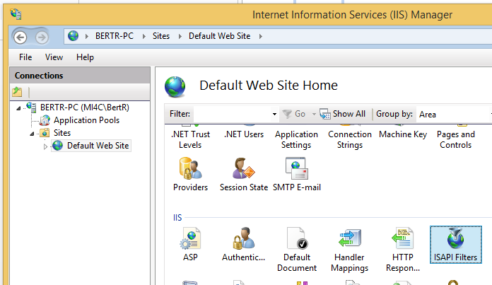
- Click on ‘add’ in the right-side menu:
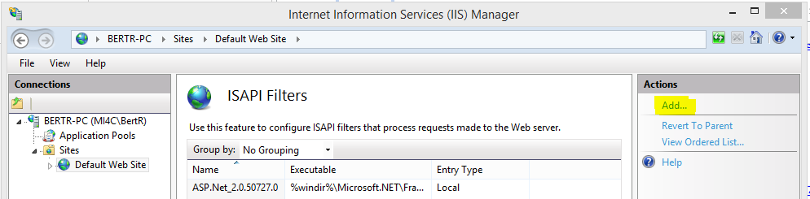
- Enter a name, and the path to AskiaExt.dll: 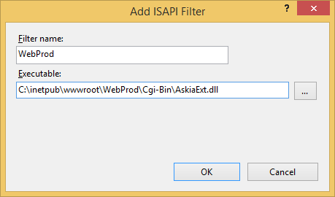
- When you click ‘OK’, you’re done! (no IISReset or application pool is necessary)

Final remarks

- You can use the original links, pretty links, and encrypted links concurrently
- When you install the ISAPI filter (and post/redirect/get is enabled) the browser will always contain the pretty URL once the interview is started (…/WebProd/Interview/JDJSJJSDJ…).
You can still start/resume new interviews using all three link types.
- When post/redirect/get is disabled and you start an interview using a pretty link, the browser will show a non-pretty link once the interview is started.
- Even if an interview is started with an encrypted link, once an interview is started you’ll always see either a pretty link or a regular link.
We could implement encryption of this link as well, if necessary

